St. John’s Methodist Church

present

Whitchurch Brass Band

**in Concert**

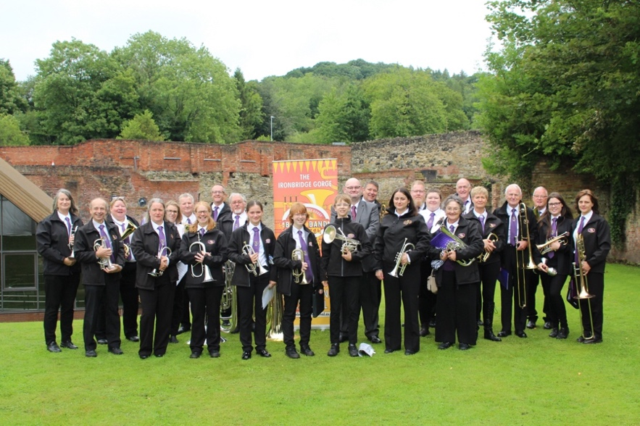

**On Saturday,**

**26th April at 6.00pm**

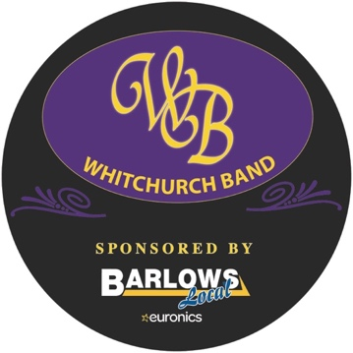 **Tickets £10.00**

***(including* *refreshments)***

**Available from ‘Barlows’ on High Street**

**or you can pay on the door**